SCHOOL

Trial WACE Examination, 2010

Question/Answer Booklet

MATHEMATICS 2C/2D(1)
SOLUTIONS

Section One:

Calculator-free

Student Number: In figures

In words

Your name

Time allowed for this section
Reading time before commencing work: 5 minutes
Working time for paper: 50 minutes

Material required/recommended for this section

To be provided by the supervisor
This Question/Answer booklet
Formula sheet

To be provided by the candidate
Standard items: pens, pencils, pencil sharpener, eraser, correction fluid, ruler, highlighters

Special items: nil

Important note to candidates

No other items may be used in this section of the examination. It is your responsibility to ensure that you do not have any unauthorised notes or other items of a non-personal nature in the examination room. If you have any unauthorised material with you, hand it to the supervisor before reading any further.

Structure of this paper

Section | Number of questions available | Number of questions to be answered | Working time (minutes) | Marks available
Section One:  Calculator-free | 7 | 7 | 50 | 40
Section Two:  Calculator-assumed | 10 | 10 | 100 | 80
 |  |  |  | 120

Instructions to candidates

- The rules for the conduct of Western Australian external examinations are detailed in the Year 12 Information Handbook 2010. Sitting this examination implies that you agree to abide by these rules.

- Write your answers in the spaces provided in this Question/Answer Booklet. Spare pages are included at the end of this booklet. They can be used for planning your responses and/or as additional space if required to continue an answer.
- Planning: If you use the spare pages for planning, indicate this clearly at the top of the page.
- Continuing an answer: If you need to use the space to continue an answer, indicate in the original answer space where the answer is continued, i.e. give the page number. Fill in the number of the question(s) that you are continuing to answer at the top of the page.

- Show all your working clearly. Your working should be in sufficient detail to allow your answers to be checked readily and for marks to be awarded for reasoning. Incorrect answers given without supporting reasoning cannot be allocated any marks. For any question or part question worth more than two marks, valid working or justification is required to receive full marks. If you repeat an answer to any question, ensure that you cancel the answer you do not wish to have marked.

- It is recommended that you do not use pencil except in diagrams.

Section One: Calculator-free (40 Marks)
This section has seven (7) questions. Answer all questions. Write your answers in the space provided.

Working time for this section is 50 minutes.

Question 1 (5 marks)
The vertices of three points are A(1, 1), B(-1, 2) and C(-2, -1).

(a) On the axes below draw the two lines, AB and BC. (1 mark)
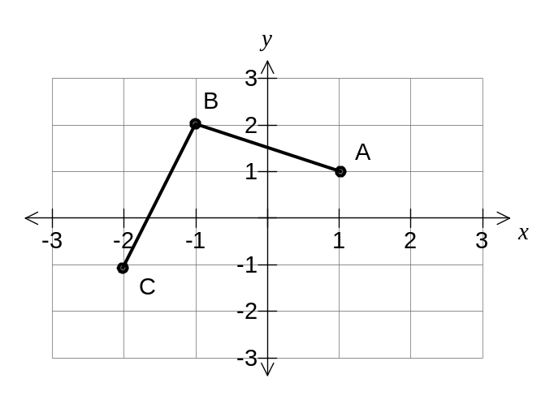

(b) Use gradients to explain whether the lines AB and BC are perpendicular. (2 marks)

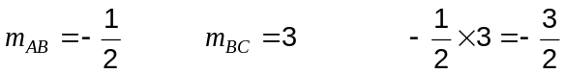

No, since perpendicular gradients have a product of -1.

(c) Determine the equation of the line through A that is parallel to the line BC. (2 marks)
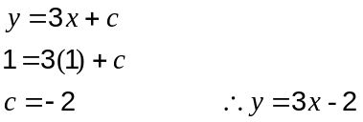

Question 2 (7 marks)
(a) Factorise

(i) 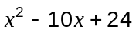 (1 mark)

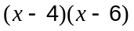

(ii) 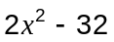 (1 mark)

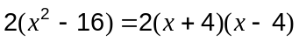

(b) Evaluate 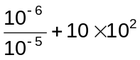 (2 marks)

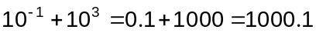

(c) Solve

(i) 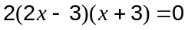 (1 mark)

(ii) 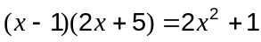 (2 marks)
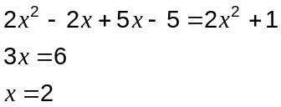
Question 3 (5 marks)
The graphs of 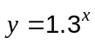 and 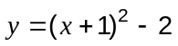 are shown below.
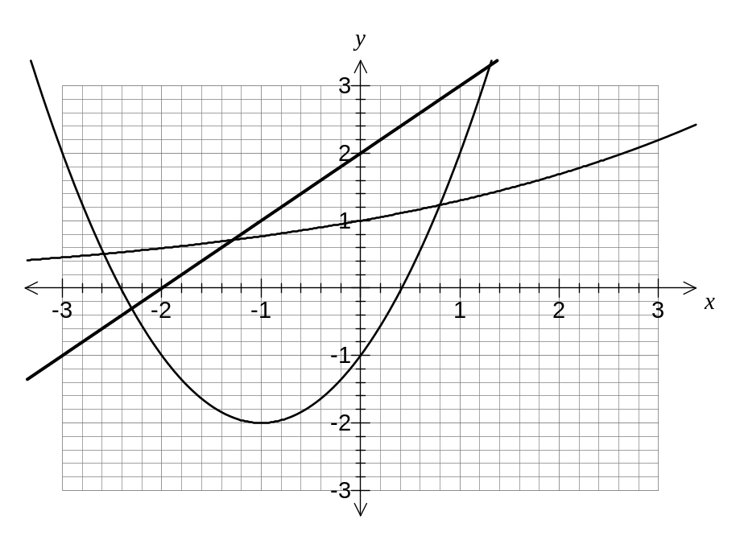
(a) Use the graph to estimate all solutions to the following equations for 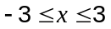, correct to 1 decimal place.

(i) 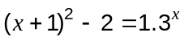 (1 mark)
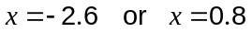

(ii) 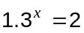 (1 mark)
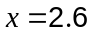

(iii) 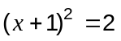 (1 mark)
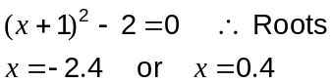

(b) In order to solve the equation 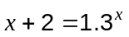 another line needs to be added to the graph. Draw the line on the graph and estimate the solution to this equation, correct to 1 decimal place. (2 marks)

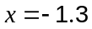

Question 4 (5 marks)
The network below shows the possible ways of linking 16 computers together using existing cabling. The numbers show the cost, in hundreds of dollars, of each link.
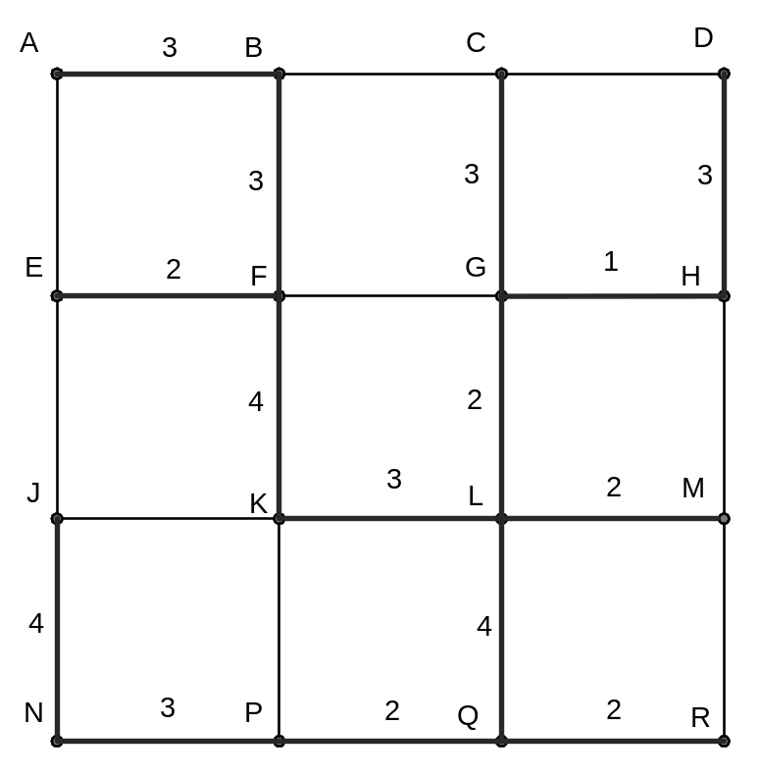

(a) Indicate clearly the minimal spanning tree on the network. (3 marks)

(b) Determine the cheapest cost of linking the computers together using the minimal spanning tree. (2 marks)
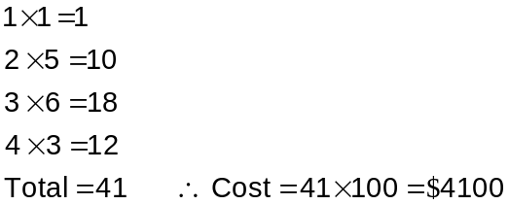

Question 5 (8 marks)
(a) Sketch the graph of 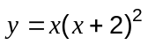 on the axes below. (3 marks)
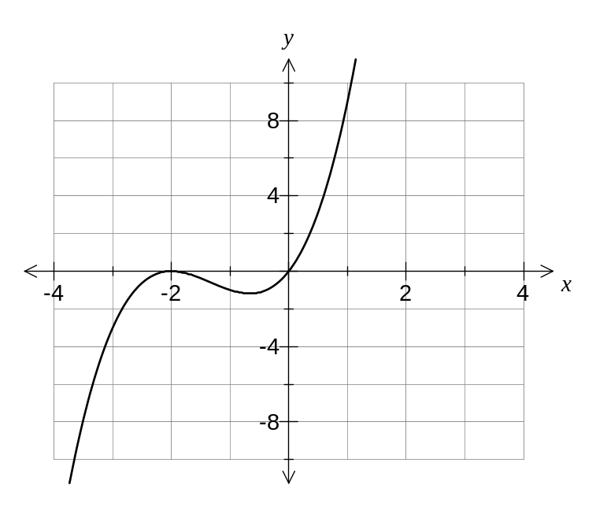
(b) Describe how the graph of 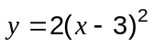 compares to the graph of 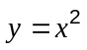. (2 marks)
The graph has been translated 3 units to the right and dilated vertically by a scale factor of 2.

(c) The point A lies at the intersection of the curve 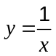 and the line 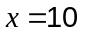. What are the coordinates of A? (1 mark)
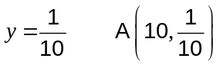

(d) State whether the relationship between the variables and in the table below is linear, quadratic, cubic, exponential or reciprocal. Justify your answer. (2 marks)

 | 1 | 2 | 3 | 4
 | 3 | 9 | 27 | 81

Exponential.
As the x-values increase by 1, so the y-values increase by a factor of 3.

Question 6 (4 marks)
Consider the right-triangle below, with sides of length 14, 48 and 50cm. The triangle is not drawn to scale. A table of values for the sine ratio for angles between 10° and 20° is also shown.

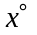 | 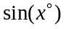
10 | 0.1736
11 | 0.1908
12 | 0.2079
13 | 0.2250
14 | 0.2419
15 | 0.2588
16 | 0.2756
17 | 0.2924
18 | 0.3090
19 | 0.3256
20 | 0.3420
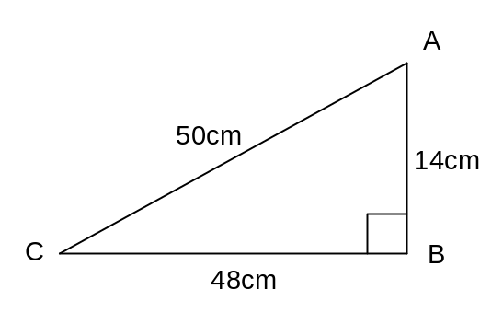

Calculate the sizes of the two acute angles in triangle ABC, to the nearest degree.

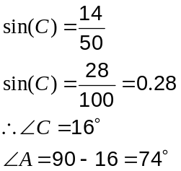

Question 7 (6 marks)
A newspaper article quoted the following data for the median house price in Western Australia for selected dates:

Date | Median Price ($000's)
June 2006 | 395
Sept 2006 | 430
Sept 2007 | 455
June 2008 | 445
Sept 2009 | 460
Dec 2009 | 485
March 2010 | 500

(a) Use the graph paper below to draw a scatter diagram for this data. (3 marks)
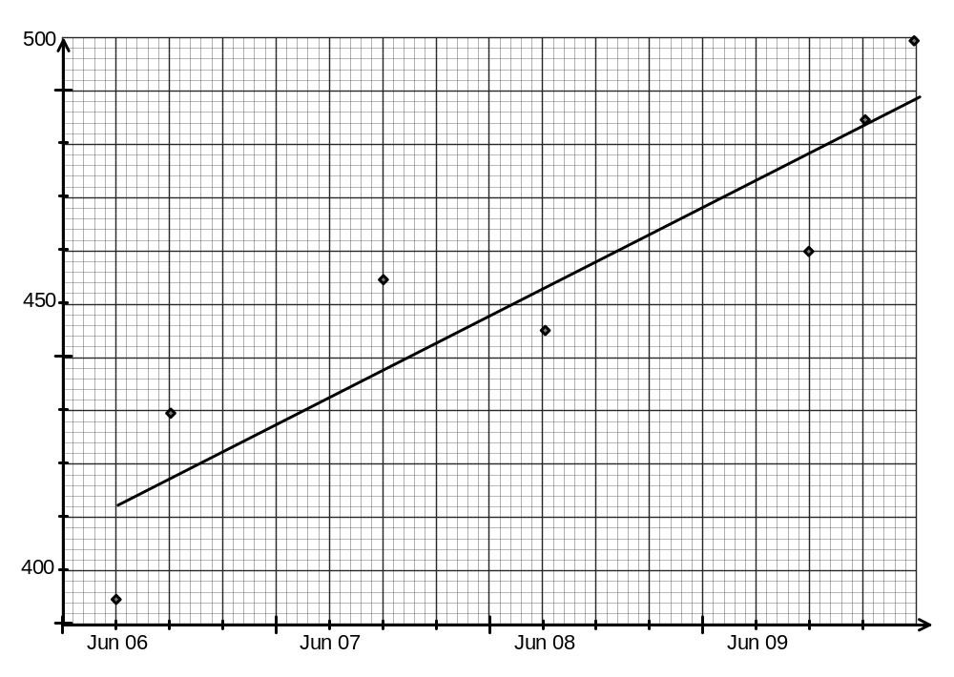
(b) Fit a trend line to your graph. (1 mark)

(c) Describe the trend shown by the data. (1 mark)
The median price is increasing with time.

(d) Use your graph to estimate the median house price in March 2009. (1 mark)
$468 000

Additional working space

Question number(s):

Additional working space

Question number(s):

